Martha Wetzel

ECON 771

Assignment 3

1. The following table presents descriptive statistics from Ericson (2014).

| **Variable** | **2006 N=1429** | **2007 N=658** | **2008 N=202** | **2009 N=68** | **2010 N=107** |
| --- | --- | --- | --- | --- | --- |
| Mean monthly premium | 37.43 (12.86) | 40.31 (17.15) | 35.96 (19.57) | 30.27 (5.34) | 32.71 (9.22) |
|  | | | | | |
| Mean deductible | 92.25 (115.79) | 114.10 (127.74) | 146.29 (124.91) | 253.43 (101.87) | 118.04 (138.74) |
|  | | | | | |
| Fraction enhanced benefit | 0.43 | 0.43 | 0.58 | 0.03 | 0.69 |
|  | | | | | |
| Fraction of plans offered by firms already offering a plan in the US | 0 | 0.76 | 0.98 | 1 | 0.97 |
|  | | | | | |
| Fraction of plans offered by firms already offering a plan in the same state | 0 | 0.53 | 0.91 | 0.68 | 0.86 |
|  | | | | | |
| Number of unique firms | 51 | 38 | 16 | 5 | 6 |
|  | | | | | |

1. A recreation of Figure 3 from Ericson (2014) is presented below.

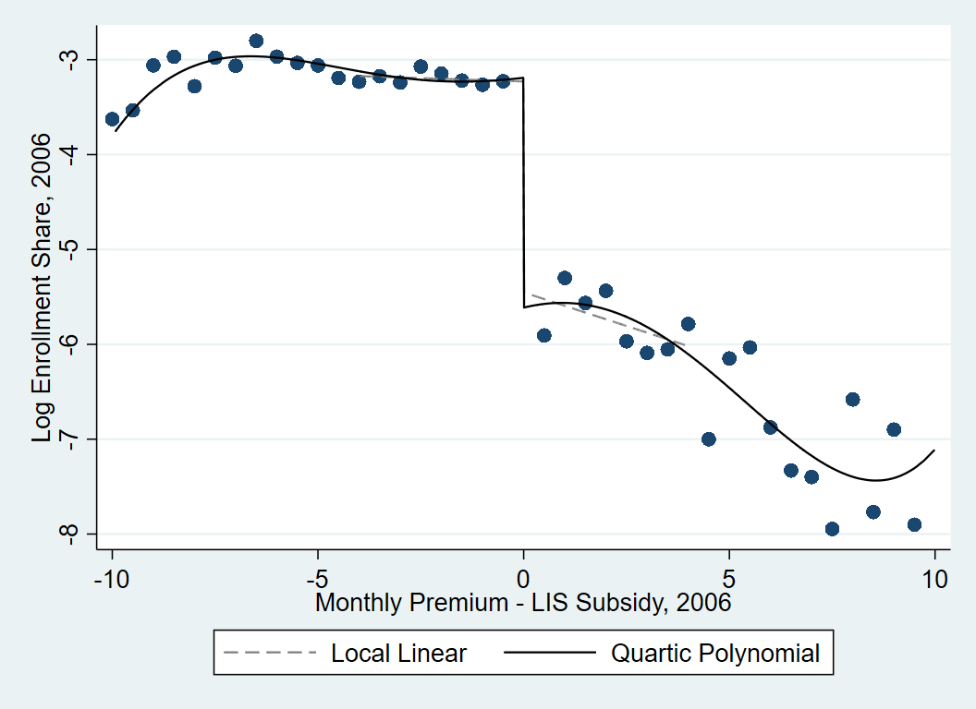

1. Variants of the graph provided in the text, using different numbers of bins, are provided below.





1. The integrated mean square error (IMSE) evenly spaced optimal bins method results in six bins below the discontinuity point and five bins above the discontinuity.

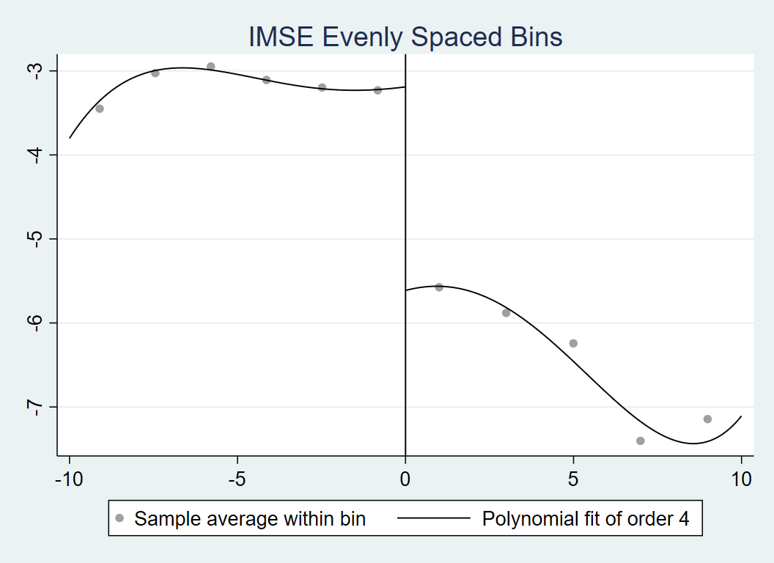

1. The manipulation test shows weak evidence for manipulation (p=0.08) of the running variable in 2006, when using the data-driven bandwidth of 12.3 for below the discontinuity and 11.9 for above the discontinuity. This result is sensitive to bandwidth selection. When a bandwidth of 4 is used, as is the basis of Table 3 in the paper, the results from this test are insignificant. Furthermore, in 2010, the last year of the measurement period, there is no evidence of manipulation (p=0.48). This presents an interesting paradox; if manipulation is possible, one would expect more manipulation after plans have had several years to learn the system and hone their manipulation skills.
2. The table below reproduces Panels A and B from Table 3 of Ericson 2014.

**Table 3 Panel A: Effect of LIS Benchmark Status in 2006 on Plan Enrollment**

|  |  |  |  |  |  |
| --- | --- | --- | --- | --- | --- |
|  | (1) | (2) | (3) | (4) | (5) |
|  | 2006 | 2007 | 2008 | 2009 | 2010 |
| Below benchmark, 2006 | 2.224*** | 1.332*** | 0.902*** | 0.803** | 0.677 |
|  | (0.283) | (0.267) | (0.248) | (0.362) | (0.481) |
|  |  |  |  |  |  |
| Premium less subsidy, 2006 Below benchmark | -0.0141 | -0.0774 | -0.0731 | -0.170 | -0.215** |
|  | (0.0322) | (0.0882) | (0.116) | (0.105) | (0.0878) |
|  |  |  |  |  |  |
| Premium less subsidy, 2006 Above benchmark | -0.142* | -0.0331 | 0.0494 | 0.0737 | 0.0488 |
|  | (0.0783) | (0.110) | (0.163) | (0.170) | (0.202) |
|  |  |  |  |  |  |
| Observations | 306 | 299 | 298 | 246 | 212 |

*** 1% ** 5% * 10%

**Table 3 Panel B: Effect of LIS Benchmark Status in 2006 on Plan Enrollment**

|  |  |  |  |  |  |
| --- | --- | --- | --- | --- | --- |
|  | (1) | (2) | (3) | (4) | (5) |
|  | 2006 | 2007 | 2008 | 2009 | 2010 |
| Below benchmark, 2006 | 1.999*** | 1.066*** | 0.630*** | 0.483** | 0.411 |
|  | (0.318) | (0.259) | (0.179) | (0.219) | (0.328) |
|  |  |  |  |  |  |
| Observations | 591 | 529 | 527 | 450 | 387 |

*** 1% ** 5% * 10%

1. The table below provides the estimates for the effect of LIS benchmark status in 2006 on plan enrollment, re-estimated using data-driven bandwidth selection. Note: The signs are inverted because the original table presents the effect of being below the benchmark instead of being above the benchmark.

**Re-estimation of Effect of LIS Benchmark Status in 2006 on Plan Enrollment**

|  |  |  |  |  |  |
| --- | --- | --- | --- | --- | --- |
|  | (1) | (2) | (3) | (4) | (5) |
|  | 2006 | 2007 | 2008 | 2009 | 2010 |
| RD Estimate | -2.201*** | 0.0912 | -0.804*** | -0.746** | -0.510 |
|  | (0.260) | (0.278) | (0.267) | (0.321) | (0.366) |
| Observations | 810 | 564 | 739 | 652 | 557 |

*** 1% ** 5% * 10%

1. The following table provides estimates of the effect of prior year enrollment on premiums, using below-benchmark status in the prior year as an instrument for enrollment. It’s important to keep in mind that the Ericson results include the plans in their first year of existence in the analysis; inherently, plans that are in their first year of existence are excluded from the IV results because they do not have a value for prior year’s market share. This nearly halves the number of observations included in the analysis and also changes the reference category for year of existence.

**IV Estimates**

|  |  |  |  |
| --- | --- | --- | --- |
|  | (1) | (2) | (3) |
| Market share in previous year | -0.0668*** | -0.0632*** | 0.0121 |
|  | (0.0110) | (0.00823) | (0.0187) |
|  |  |  |  |
| Year of plan existence, Second | -0.434*** | -0.414*** | -0.460*** |
|  | (0.0859) | (0.144) | (0.0902) |
|  |  |  |  |
| Year of plan existence, Third | -0.352*** | -0.347*** | -0.368*** |
|  | (0.0925) | (0.127) | (0.131) |
|  |  |  |  |
| Year of plan existence, Fourth | -0.117** | -0.0925 | -0.125* |
|  | (0.0476) | (0.0783) | (0.0705) |
|  |  |  |  |
| Constant | 3.509*** | 3.445*** | 3.659*** |
|  | (0.0639) | (0.0628) | (0.0865) |
| Observations | 2725 | 2725 | 2725 |

*** 1% ** 5% * 10%

All models contain year and state interaction fixed effects, are limited to basic plans, and have standard errors clustered at the firm level. Model 2 contains whether the firm offers a Medicare Advantage plan as a covariate. Models 2 and 3 contain covariates relating to the type of basic plan. Model 3 adds firm-level fixed effects.

1. The results of adjusting the bin width for the figures does not change the overall story told by the graphs. The smoothest graphs may be easier interpret, but the overall finding of the discontinuity is the same. Changing the bandwidth has differing effects depending on the magnitude of the change. After reversing the sign to handle the slight specification change, most of the new estimates are similar in magnitude to the original Ericson estimates; the one exception is 2007. The data-driven bandwidths for the other years ranged from 3.6 to 4.5. In contrast, the bandwidth for 2007 was 2.4. Unsurprisingly, the bandwidth that differed the most from the originally chosen bandwidth produced the most divergent result.

The IV results provide an interesting addition to the results presented in the paper. Among the plans in their second or later year of existence, the majority of the variation in premiums is within plan variation, as opposed to between-plan variation. When plan-level fixed effects are included, the effect of market share in the prior year becomes insignificant. However, plans still appear to be charging lower premiums in their earlier years of existence relative to the fifth year of existence. This is in line with the “invest then harvest” strategy.